WED5020: Project Proposal
Student name:Keabetswe Tselanngwe
Student number:ST10505914
Date of submission: 30 July 2026

Table of content
Proposal one: Kota masters 2
Proposal one: Kota masters 2
-Mission and Vision 2
-Target audience 2
-Goals and objectives 2
-Features and functionality 3
-Design and user experience 3
-Budget 4
-Proposal two: Kwa Olga 4
-Overview and brief history of Kwa Olga 4
Mission and Vision: 5
Target Audience 5
Current Website Analysis 5
Features and Functionality 5
Design and User Experience 5
Technical Requirements 6
Project Timeline 6
Budget 7
Reference 8

Proposal one: Kota masters
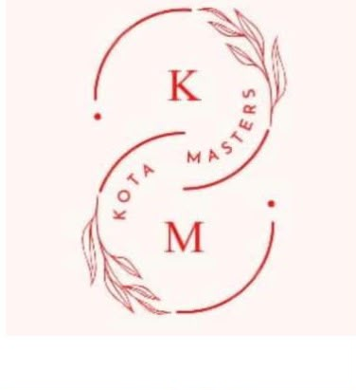
-Overview and Brief history
Located on 7th Avenue in Roodepoort, Kota Masters is a small culinary business run by two female entrepreneurs, founded in 2018. The company is well-known in the neighbourhood for offering freshly made, reasonably priced, excellent kotas. Through word-of-mouth recommendations and first-rate customer service, Kota Masters has amassed a devoted clientele over the years. High school students from surrounding schools, local police officers, locals and travellers passing through Roodepoort are among its frequent patrons.
Source: Kota Masters Facebook page (2022).
From R12 to R200, the company sells a large range of kotas. Chips in various sizes, bottled water, Liqui Fruit juices, Cool Time ice pops and canned and bottled soft beverages including Sprite and Coca-Cola are all available for purchase. Every morning, the breakfast buffet includes freshly cooked fat cakes; catering platters are available upon request for special occasions, enterprises and educational institutions. Despite its popularity, Kota Masters lacks an official website now.

-Mission and Vision
- To offer reasonably priced, freshly made meals with outstanding customer service in a friendly setting.
To become Roodepoort's top takeout company by fusing high-quality cuisine with a polished web presence that enhances client convenience.

-Target audience
High school students, police officers, office professionals, locals, families and commuters would all be the target audience for the planned website. Customers searching for catering platters and easy access to the company's menu and services will also find it appealing.

-Goals and objectives
The website's goal is to provide Kota Masters with a professional internet presence. It will display the menu, costs, breakfast options, drinks and catering services, and provide clients with directions, contact details and business hours. The website will attract new clients, increase brand recognition, and facilitate better connections with current clients.

-Features and functionality
Home, About Us, Menu, Breakfast, Catering, Gallery, Contact Us, and Location pages are all part of the website. Clients will be able to view menu items, see prices, enquire about catering services, and use Google Maps to find the company.

-Design and user experience
The website will feature a contemporary, mobile-friendly, and responsive design. Red, yellow, black, and white will make up the colour scheme, giving it a vibrant aspect that is representative of the food sector. To maintain readability and professionalism, headings shall be written in Poppins, while body text will be written in Arial.
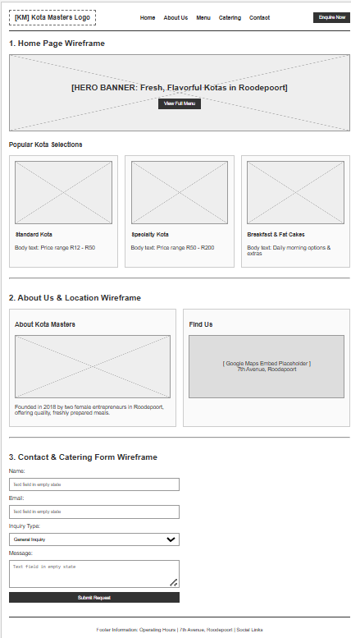
Source: Keabetswe, created using Canva (2026).
-Project Timeline
Activity | Duration | Planned dates
Research | 23 July-31 July 2026 | 9 days
Planning | 1 August-7 August 2026 | 1 week
Website Design (Wireframes and Layout | 8 August-14 August 2026 | 1 week
Website Development (part 1-HTML) | 1 August-14 August 2026 | 2 weeks
Website development (part 2: CSS styling and JavaScript) | 15 August – 18 September | 5 weeks
Testing and refinements | 19 September-10 October 2026 | 3 weeks
Domain registration and hosting | October-November 2026(before final submission) | Approximately 2-3

-Budget
Activity | Estimated cost
Research | R500
Planning | R800
Website Design | R 1 500
Website Development | R3 000
Testing | R700
Domain Registration and hosting | R1 200
Total estimated budget | R7 700

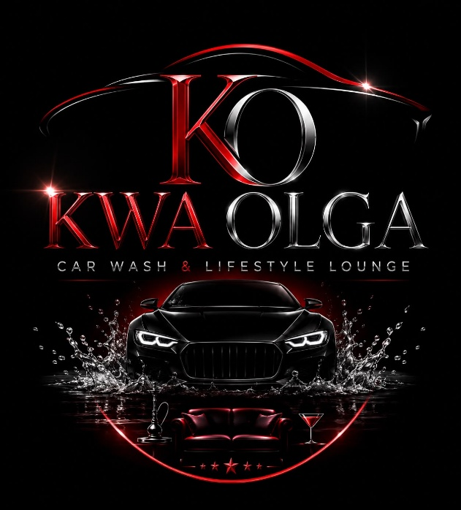

-Proposal two: Kwa Olga

-Overview and brief history of Kwa Olga
Kwa Olga, a new premium car wash and lifestyle lounge opening on October 31 in Meadowlands, Soweto, offers a unique concept that combines professional car cleaning with a vibrant social lounge specifically designed for adults. Inspired by South African kasi culture, Kwa Olga creates a welcoming atmosphere where guests can enjoy lively music, delicious food, refreshing beverages and exceptional service. Admission is strictly for those aged 21 and up.
Source: Keabetswe, created using Canva (2026).

Mission and Vision:
-To offer top-notch car washing services while fostering a fun, safe, and lively social atmosphere that honours South African township culture.
-To become Soweto's top lifestyle car wash and social lounge by providing first-rate auto care, outstanding customer service, and unforgettable client experiences.

Target Audience
Kwa Olga caters to people between the ages of 21 and 45, including young professionals, business owners, auto enthusiasts and groups of friends seeking a first-rate car wash experience together with a lively, laid-back social setting that embodies township culture.
Goals and Objectives
Before its formal opening, the planned website would set up Kwa Olga's online presence, market weekly events and promotions, highlight car cleaning packages, raise brand recognition, and enable online reservations and inquiries.

Current Website Analysis
Kwa Olga does not yet have a website because it is a new company. Before launching, creating a polished website will increase anticipation, boost credibility and draw clients.

Features and Functionality
Home, About Us, Services, Price List, Specials & Events, Gallery, Bookings, Contact Us, and Location pages will all be included on the website. Valet, exterior wash, deep clean and detailing packages will be available for customers to peruse. They may also check weekly promos, submit inquiries, and use Google Maps to find the company.

Design and User Experience
The website will have a high-end, contemporary, and adaptable design. While modest orange accents will draw attention to promotions and action buttons, a colour scheme of matte black, scarlet, charcoal grey, and white will create an elegant and opulent impression. To guarantee outstanding readability and a polished look, Open Sans will be used for body text and Montserrat for headers. The design will be simple, eye-catching, mobile- and desktop device-friendly.
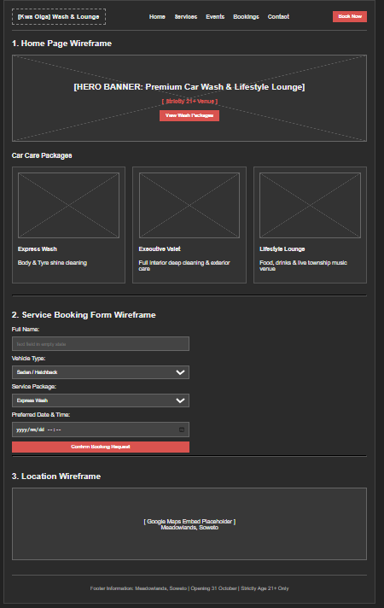
Source: Keabetswe, created using Canva (2026).

Technical Requirements
Visual Studio Code will be used to create the website, utilising HTML for page structure, CSS for responsive layouts and styling, and JavaScript for interactive features like image galleries, booking forms, event announcements and navigation menus.

Project Timeline
Activity | Duration | Planned Dates
Research | 23 July – 31 July 2026 | 9 Days
Planning | 1 August – 7 August 2026 | 1 Week
Website Design (Wireframes & Layout Planning) | 8 August – 14 August 2026 | 1 Week
Website Development – Part 1 (HTML) | 1 August – 14 August 2026 | 2 Weeks
Website Development – Part 2 (CSS Styling & JavaScript) | 15 August – 18 September 2026 | 5 Weeks
Testing and Refinements | 19 September – 10 October 2026 | 3 Weeks
Domain Registration and Hosting | October – November 2026 (before final submission) | Approximately 2–3 Weeks

Budget
Activity | Estimated Cost
Research | R600
Planning | R1,000
Website Design | R2,000
Website Development | R3,500
Testing | R900
Domain Name and Web Hosting | R1,500
Total Estimated Budget | R9,500

Reference
Canva. (2026). Canva: Visual suite for design. https://www.canva.com/ (accessed date 30 Jul. 26)
Duckett, J. (2021). HTML and CSS: Design and build websites. John Wiley & Sons. (accessed date 30 Jul. 26)
Facebook. (n.d.). Kota Masters [Facebook page]. Retrieved July 30, 2026, from https://www.facebook.com/ . (accessed date 30 Jul. 26)
Flanagan, D. (2020). JavaScript: The definitive guide (7th ed.). O'Reilly Media.
GitHub. (2026). GitHub Docs. https://docs.github.com/ . (accessed date 30 Jul. 26)
Krug, S. (2014). Don't make me think, revisited: A common sense approach to web usability (3rd ed.). New Riders. (accessed date 30 Jul. 26)
Mozilla Developer Network. (2026). CSS: Cascading Style Sheets (CSS). https://developer.mozilla.org/en-US/docs/Web/CSS . (accessed date 30 Jul. 26)
Mozilla Developer Network. (2026). HTML: HyperText Markup Language (HTML). https://developer.mozilla.org/en-US/docs/Web/HTML . (accessed date 30 Jul. 26)
Mozilla Developer Network. (2026). JavaScript Guide. https://developer.mozilla.org/en-US/docs/Web/JavaScript . (accessed date 30 Jul. 26)
Pinterest. (n.d.). Kota meal image [Photograph]. Retrieved July 30, 2026, from https://www.pinterest.com/ . (accessed date 30 Jul. 26)
Pinterest. (n.d.). Premium car wash image [Photograph]. Retrieved July 30, 2026, from https://www.pinterest.com/ (accessed date 30 Jul. 26)
Visual Studio Code. (2026). Visual Studio Code documentation. https://code.visualstudio.com/docs . (accessed date 30 Jul. 26)

